**A Comparison of Hydropower and Fossil Fuel Greenhouse Gas Emissions**

Natalie Kadonaga

HAS 10-5 The Economics of Oil and Energy

March 3, 2016

**I. Introduction**

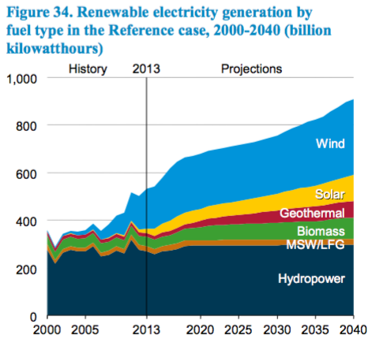In order to support a growing electricity demand and decrease reliance on importing foreign fuel, many countries may look to diversify their sources for electricity generation. Renewable sources are prioritized due to the environmental externalities that result from the greenhouse gas emissions of traditional fuels. This increase in renewable electricity generation is supported by the Annual Energy Outlook from 2015 (AEO 2015) from the U.S. Energy Information Administration (EIA), which predicts that renewable electricity generation will grow through 2040, based on “state and national policy requirements.”[1] This leads one to speculate which of the renewable sources will become the most predominant.

As shown by figure 1, the current largest source of US renewable electricity generation is from hydropower. Therefore, one could predict that hydropower will maintain dominance in terms of generation as renewable electricity generation expands. However, figure 1 shows wind to out-generate hydropower by the year 2040. The numbers for the 2040 predictions are shown in figure 2, with wind producing 317.1 billion kWh and conventional hydropower producing 295.6 billion kWh. As also shown by figure 2, conventional hydroelectric power generation will have an annual growth rate of 0.4%, the lowest growth rate out of all other renewable energy sources. Why have sources such as wind and solar been predicted to prevail over hydropower, despite hydropower historically dominating renewable electricity generation?

Figure . A graph from the U.S. Energy Information Administration’s Annual Energy Outlook in 2015.

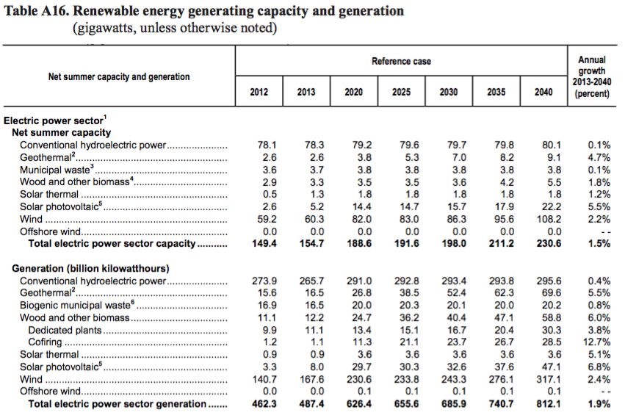

Figure . A table from the U.S. Energy Information Administration’s Annual Energy Outlook in 2015. Conventional hydroelectric power does not include pumped storage hydroelectric, which is considered “a nonrenewable storage medium for fossil and nuclear power.” It also does not include “offshore or in-stream hydroelectric, efficiency or operational improvements without capital additions, or additional potential from refurbishing existing hydroelectric capacity.”[2]

One may theorize that the negative effects of hydropower facilities may cause this decreased emphasis on its use in future decades. Although hydropower is considered a renewable source of energy because its fuel, water, is essentially free, an examination of its relatively unrecognized environmental externalities suggests that it is not the optimal candidate for expansion. In this paper, we will discuss the consequences of hydroelectric power generation and why it is not a viable option for expansion in the United States by explaining its current technology and comparing its greenhouse gas emissions with those of traditional fossil fuels.

**II. The Process behind Hydroelectric Power Generation**

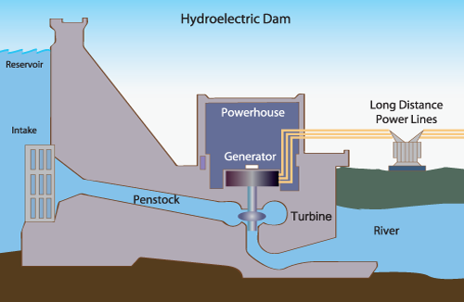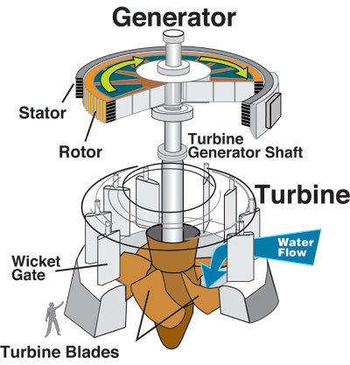In order to understand the environmental impact of hydroelectric plants, we require a rudimentary explanation of their construction. The basic concept of a hydroelectric plant is harnessing the mechanical energy of moving water in rivers and converting the mechanical energy into electricity. A typical dam is built on a large river with a large drop in elevation, so that water will flow from a location with high gravitational potential energy to one of low gravitational potential energy, turning that loss in potential energy into kinetic, or motion energy. The greater the amount of water and drop in elevation, the greater the rate of water flow.[3] Building a dam increases this drop in elevation, which raises the elevation of the river’s water upstream. Figure 3 shows a visual representation of a typical hydroelectric dam. This area with raised water levels serves as storage for water and floods the vegetation and soil between the old water level and the new water level. This paper will eventually discuss the methane emissions that result from the flooding of these areas.[4]

Figure . A diagram of a hydroelectric generator courtesy of U.S. Army Corps of Engineers.

Figure . A diagram of a typical hydroelectric dam. In this case, the water would flow from left to right.

When electricity needs to be generated, the intake releases water from the reservoir and the water goes through a penstock to go through turbine propellers. As shown by figure 4, these propellers are connected to the turbine generator shaft, which rotate as the water flows through the propellers. Mounted around the shaft above the turbine are electromagnets, which are loops of wire around magnetic laminations. These units, called field poles, rotate while the stator, made of conductors, remains stationary. When the field poles move past the conductors, electricity flows. This electricity can then be transported across transmission lines for residential, commercial, or industrial use.[5]

**III. Causes of Reservoir Methane Emissions and Global Warming Potentials**

When reservoirs are created, they introduce bodies of water into areas with biomass and soils, killing the vegetation. At the bottom of the reservoir, sediment and bacteria collect in the oxygen-poor environment. As part of the carbon cycle, bacteria decomposes the dead biomass and releases methane gas (CH4) to the surface. This process is shown in figure 5. In deep reservoirs, some methane oxidizes to carbon dioxide gas (CO2) on the long travel to the surface. However, in shallow reservoirs, and especially in the tropics, there is little oxygen. Therefore, in these anaerobic environments, the biomass decomposes into methane instead.[6] These hydroelectric plants also emit methane from turbines, intakes, and rivers downstream.[7]

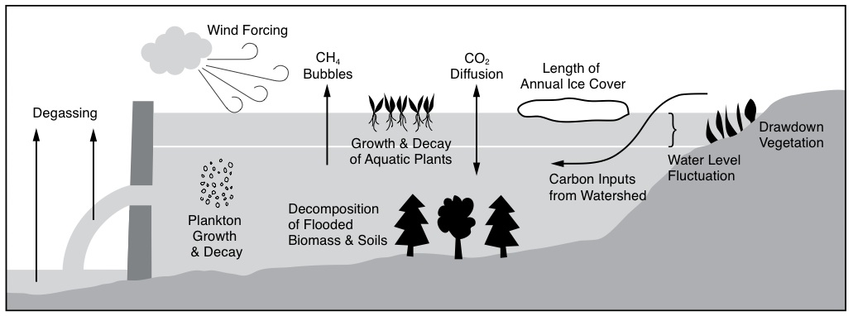

Figure . A schematic of factors that contribute to reservoir greenhouse gas emissions. We will focus on the causes of methane (CH4) emissions.

While carbon dioxide and methane are both greenhouse gases, methane is more “potent” is its effect on climate change. The Intergovernmental Panel on Climate Change (IPCC) explains this “potency” through a measurement of “global warming potential” (GWP). The GWP compares the amount of energy absorbed by the emissions of one ton of the measured greenhouse gas to the emissions of one ton of carbon dioxide.[8] The IPCC’s 2013 Anthropogenic and Natural Radiative Forcing reports the GWP of methane over 20 years to be 84-86 and over 100 years to be 28-34. The uncertainty is due to the indirect effects of methane, which include methane as a precursor to ozone, which is also a greenhouse gas. With methane’s GWP100 around 30, this means that methane absorbs 30 times more energy than carbon dioxide over the course of 100 years.[9] Therefore, with the higher potency of methane, the levels of emissions of methane from reservoirs suggest an interesting foundation for a comparison with the greenhouse gas emissions of fossil fuels, which is mostly CO2.[10]

**IV. Comparing Brazilian Reservoir and Fossil Fuel Emissions**

Philip Martin Fearnside, a research professor in the Department of Ecology at the National Institute for Research in the Amazon, published a paper which measured and calculated the 1990 emissions from tropical reservoirs in million tons of carbon dioxide equivalent per terawatt-hour. He compared this with other emissions shown in in figure 6. His shocking conclusion was that Balbina Dam in Brazil had 20 times the impact on global warming than generating the same power from traditional fuels.[11]

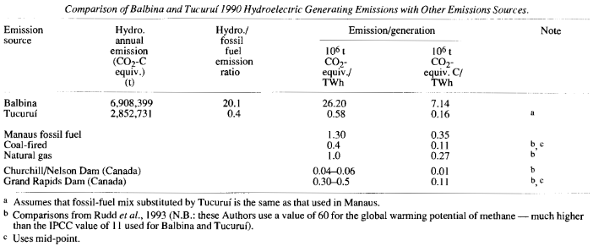

Figure . A table from Fearnside comparing emissions per terawatt-hour for tropical reservoirs in Brazil, traditional fuels, and reservoirs in Canada.

We will expand this by comparing these results to emissions of fossil fuels and converting all measurements to pounds carbon dioxide equivalent per kWh.

Balbina’s emissions are given as 26.20 106 t CO2e/TWh. There are 2,000 pounds in a ton, so there are 2,000 * 1,000,000 pounds in 1 million tons. There are 1,000,000,000 kWh in a TWh. Therefore, to convert 106 t CO2e/TWh to pounds CO2e/kWh, we multiply 26.20 by (2,000 * 1,000,000 / 1,000,000,000) to get **52.4 pounds CO2e/kWh**.

We perform the same calculation for Tucuruí, Churchill/Nelson, and Grand Rapids to get **1.16 pounds CO2e/kWh**, **0.12 pounds CO2e/kWh,** and **1.00 pounds CO2e/kWh** respectively.

In another one of Fearnside’s papers, he calculated the 106 t CO2e as 0.15 for Curuá-Unã, another reservoir in Brazil, and its generation over one year as 0.19 TWh.[12] Therefore, to calculate its 106 t CO2e/TWh we just divide 0.15 by 0.19 to get 0.789. We multiply 0.789 by (2,000 * 1,000,000 / 1,000,000,000) to get **1.58 pounds CO2e/kWh**.

Now that we have calculated the emissions for reservoirs in different climates, we will move on to calculate emissions of fossil fuels from EIA data. We will calculate the pounds CO2e/kWh for the following fossil fuels: bituminous coal, subbituminous coal, lignite coal, natural gas, distillate oil, and residual oil. The EIA gives these emissions in units of pounds CO2e/kWh, so we do not need to convert these units.[13]

At last, the emissions in pounds CO2e/kWh can be consolidated into the bar chart in figure 7.

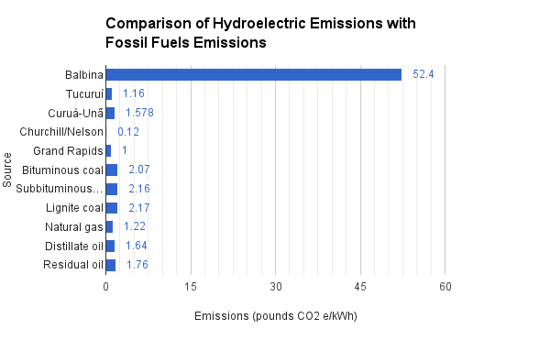

Figure . A chart representing the calculated emissions per generation for several hydroelectric dams and fossil fuels.

An examination of our table shows that the emissions per kWh for the Brazilian reservoirs in tropical climates, Balbina, Tucuruí, and Curuá-Unã, have substantial greenhouse gas emissions when compared to fossil fuel plants. The worst case is Balbina, which flooded a large area of tropical forest, but does not produce much electricity to make up for it. This case is clearly an outlier, but its existence should serve as a fair warning to carefully evaluate the environmental impacts of hydroelectric dams in similar climates should dams continue to be built.

The smaller Canadian reservoirs in boreal climates, Churchill/Nelson and Grand Rapids, do not produce the same levels of methane emissions to match those of the tropical reservoirs. Experts suspect that the warmer temperatures of tropical climates promote faster decomposition of dead biomass.[14] However, the levels of methane emissions are still comparable to the fossil fuel emissions, which indicates that the environmental externalities should be considered even in smaller reservoirs with colder climates.

**V. Conclusion**

Although using hydroelectric power is attractive for its cheap and renewable fuel source and its independence from fossil fuels, consideration of reservoir greenhouse gas emissions comparable with those of fossil fuels indicates that hydroelectric is a poor choice for a renewable electricity generation solution. Despite a lack of scientific evidence for methane emissions in the United States, many hydroelectric plants across the United States have similar climates to those in Brazil or Canada, which suggests similar levels of methane emissions. Therefore, a greater emphasis on wind and solar electricity generation for following decades are the better option in order to decrease reliance on hydropower and contributions to climate change. [1868]

1. 1 "Annual Energy Outlook 2015 with Projections to 2040." Annual Energy Outlook 2015. April 14, 2015. Accessed March 03, 2016. http://www.eia.gov/forecasts/aeo/.
2. "Assumptions to AEO2015." Assumptions to Annual Energy Outlook - Energy Information Administration. September 10, 2015. Accessed March 3, 2016. http://www.eia.gov/forecasts/aeo/assumptions/.
3. "Hydropower Explained." Hydropower - Energy Explained, Your Guide To Understanding Energy - Energy Information Administration. May 12, 2015. Accessed March 03, 2016. https://www.eia.gov/energyexplained/index.cfm?page=hydropower_home.
4. "How Hydropower Works." How Hydropower Works. Accessed March 3, 2016. http://www.wvic.com/content/how_hydropower_works.cfm.
5. "Hydroelectric Power: How It Works." Hydroelectric Power: How It Works, USGS Water-Science School. August 7, 2015. Accessed March 03, 2016. http://water.usgs.gov/edu/hyhowworks.html.
6. "Dirty Hydro: Dams and Greenhouse Gas Emissions." Dirtyhydro_factsheet_lorez.pdf. November 2008. Accessed March 3, 2016. https://www.internationalrivers.org/files/attached-files/dirtyhydro_factsheet_lorez.pdf.
7. "Frequently Asked Questions: Greenhouse Gas Emissions from Dams." Greenhouse Gas Emissions from Dams FAQ | International Rivers. May 1, 2007. Accessed March 03, 2016. https://www.internationalrivers.org/resources/greenhouse-gas-emissions-from-dams-faq-4064.
8. "Understanding Global Warming Potentials." Understanding Global Warming Potentials | Climate Change | US EPA. February 23, 2016. Accessed March 03, 2016. http://www3.epa.gov/climatechange/ghgemissions/gwps.html.
9. Myhre, G., D. Shindell, F.-M. Bréon, W. Collins, J. Fuglestvedt, J. Huang, D. Koch, J.-F. Lamarque, D. Lee, B. Mendoza, T. Nakajima, A. Robock, G. Stephens, T. Takemura and H. Zhang, 2013: Anthropogenic and Natural Radiative Forcing. In: Climate Change 2013: The Physical Science Basis. Contribution of Working Group I to the Fifth Assessment Report of the Intergovernmental Panel on Climate Change [Stocker, T.F., D. Qin, G.-K. Plattner, M. Tignor, S.K. Allen, J. Boschung, A. Nauels, Y. Xia, V. Bex and P.M. Midgley (eds.)]. Cambridge University Press, Cambridge, United Kingdom and New York, NY, USA.
10. "Overview of Greenhouse Gases." Greenhouse Gas Emissions: Greenhouse Gases Overview | Climate Change | US EPA. February 24, 2016. Accessed March 03, 2016. http://www3.epa.gov/climatechange/ghgemissions/gases.html.
11. Fearnside, Philip M. "Hydroelectric Dams in the Brazilian Amazon as Sources of ‘Greenhouse’ Gases." *Envir. Conserv. Environmental Conservation* 22, no. 01 (January 1995): 7. ResearchGate.
12. Fearnside, Philip M. "Do Hydroelectric Dams Mitigate Global Warming? The Case of Brazil's CuruÁ-una Dam." *Mitig Adapt Strat Glob Change Mitigation and Adaptation Strategies for Global Change* 10, no. 4 (October 2005): 675-91. Springer Link.
13. "Table A.3. Carbon Dioxide Uncontrolled Emission Factors." Electric Power Annual 2014 - U.S. Energy Information Administration. February 16, 16. Accessed March 03, 2016. https://www.eia.gov/electricity/annual/html/epa_a_03.html.
14. Pearce, Fred. "Water-Reservoirs and Greenhouse Emissions." Dams and Greenhouse Effect. October 13, 2000. Accessed March 03, 2016. http://www.rivernet.org/general/dams/greenhouse.htm.